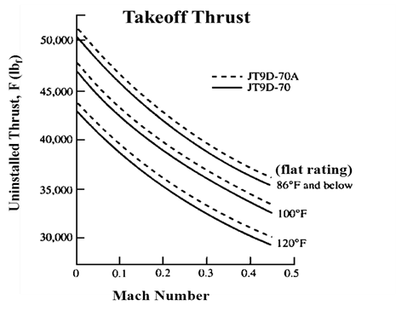

**17.2.4 Thrust Calculations**

Various formulae exist to calculate gross engine thrust (Fg). However, modern engines are too complex for standard textbook formulas to accurately predict thrust; this is normally left to complex computer algorithms. The current standard for new models is the Numerical Propulsion System Simulation (NPSS). Despite this, a control volume approach relying on conservation of momentum will provide gross engine thrust if the required parameters are known.

$$Thrust=\frac{\left({\dot{m}}_{9}+{\dot{m}}_{fuel}\right)V_{9}-{\dot{m}}_{0}V_{0}}{g_{c}}+(P_{9}-P_{0})A_{9}$$

Where subscript 9 represents the nozzle exit and subscript 0 represents the freestream conditions. $\dot{m}$, V, and, P represent mass flow rate, velocity, and static pressure respectively.

Variations and simplifications of this formula exist:

|  |  |
| --- | --- |
| Turbojet and Low Bypass Turbofan (Mixed Streams) | $$Thrust=\frac{{\dot{m}}_{0}(V_{9}-V_{0})}{g_{c}}$$ |
| High Bypass Turbofan  (Separate Streams) | $$Thrust=\frac{{\dot{m}}_{fan}}{g_{c}}(V_{fan}-V_{0})+\frac{{\dot{m}}_{core}}{g_{c}}(V_{9}-V_{0})$$ |

Atmospheric temperature, Mach, and altitude also significantly affect engine thrust and efficiency.

